Ballon defender
In the game, the enemies will follow a winding path, and the player has to try to click on them before they reach the goal. The player should avoid clicking the blue balloons as they will decrease the player's health; however, if a blue balloon reaches the goal, the player will be healed, whereas if an orange balloon reaches the goal, the player will lose health
Now, a new class is being created to store all the associated data for the enemies and to move them using a procedure inside the class.
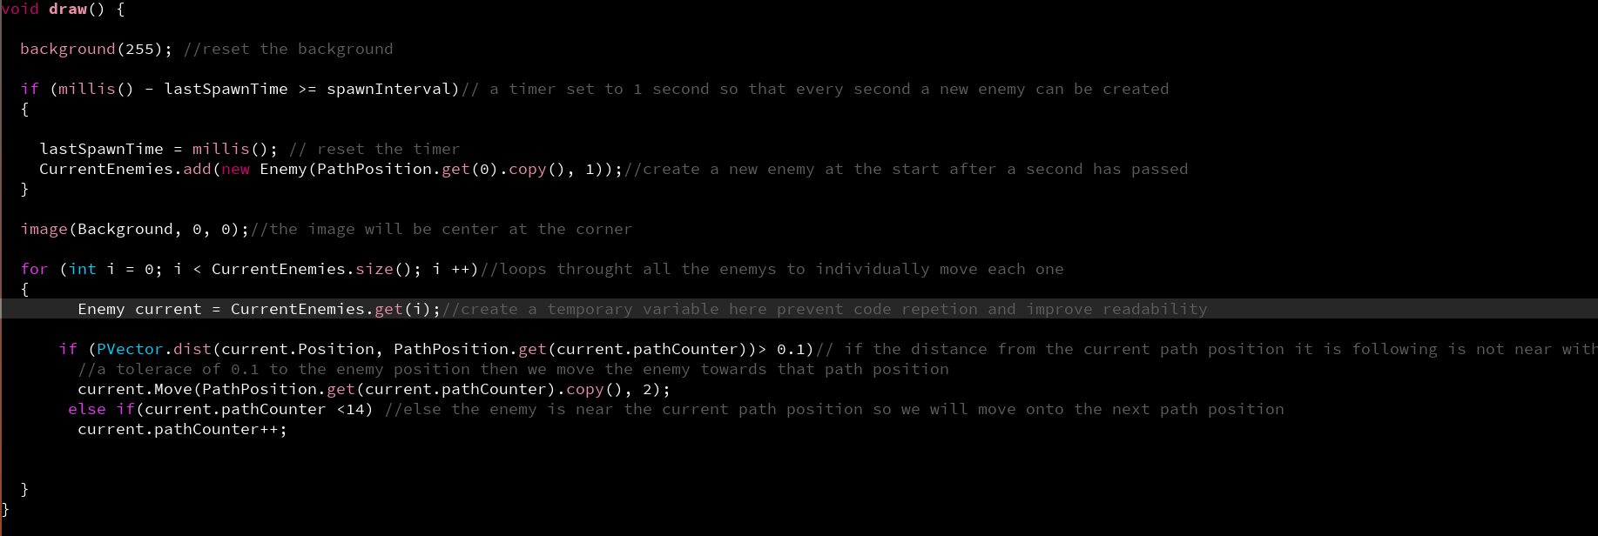
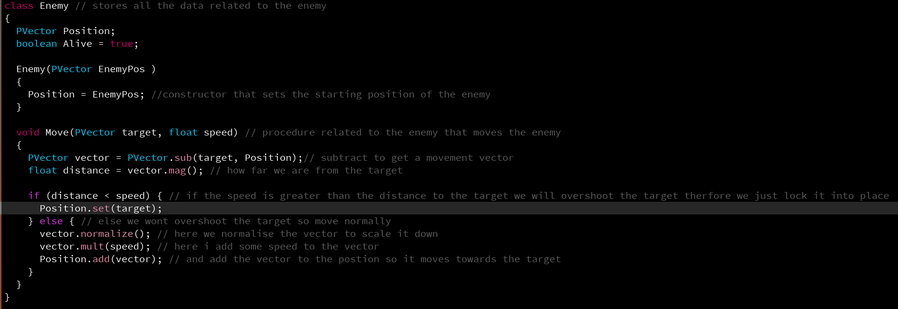
There will be multiple enemy objects, created frequently during the game runtime and stored in a list.
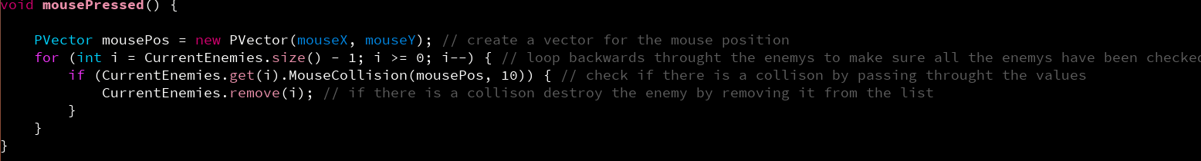
The enemy is destroyed if the mouse is pressed near the enemy.
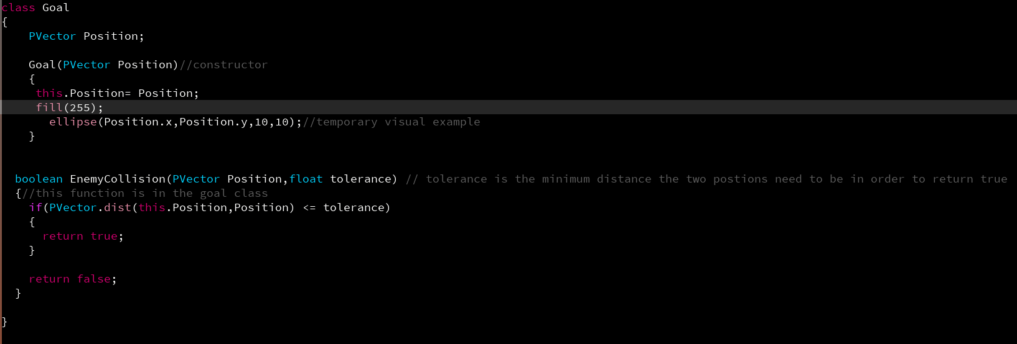
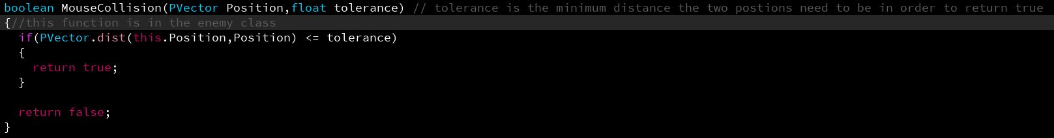
A goal class was created.
In setup()
In draw()
Global variable in the BallonDefense class
You don’t start with 5 at the start, but after 5 seconds, there will be 5 because every second a new enemy is created, so after 10 seconds, there will be 10, etc
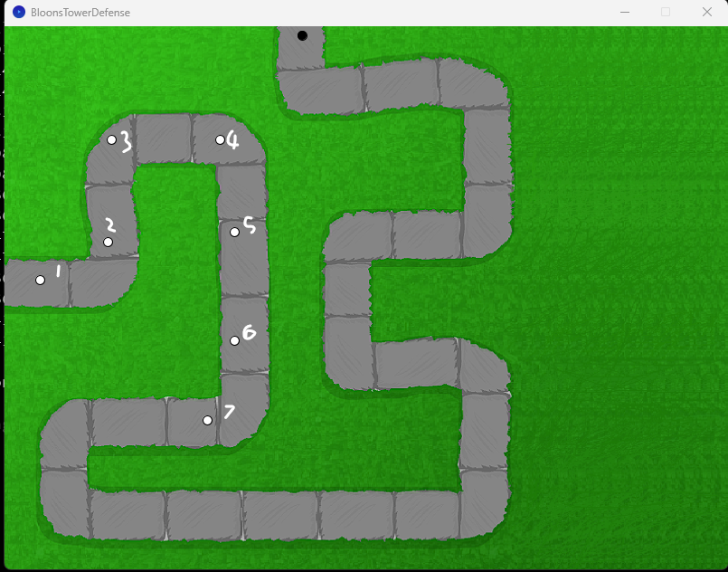
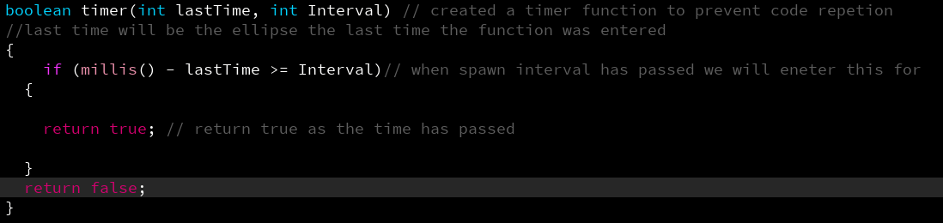
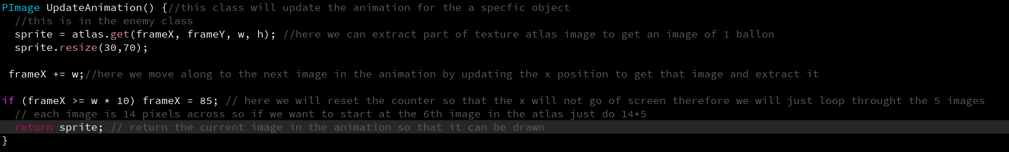
An animated sequence has been added for each balloon. 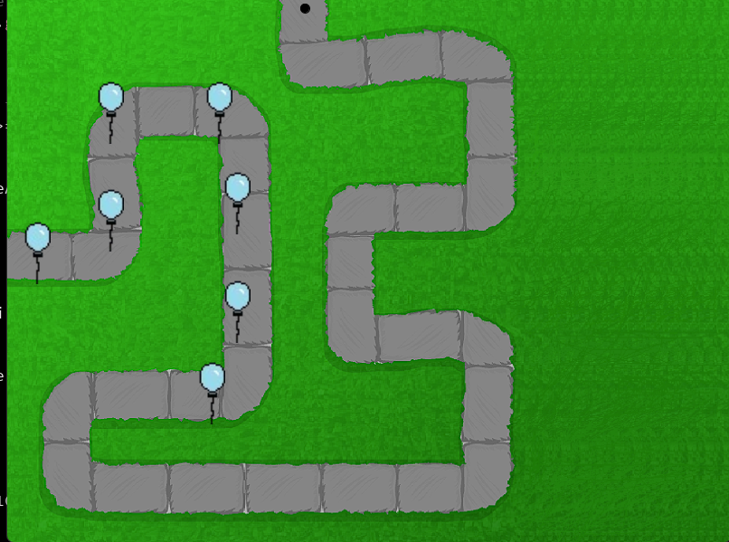

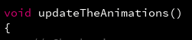
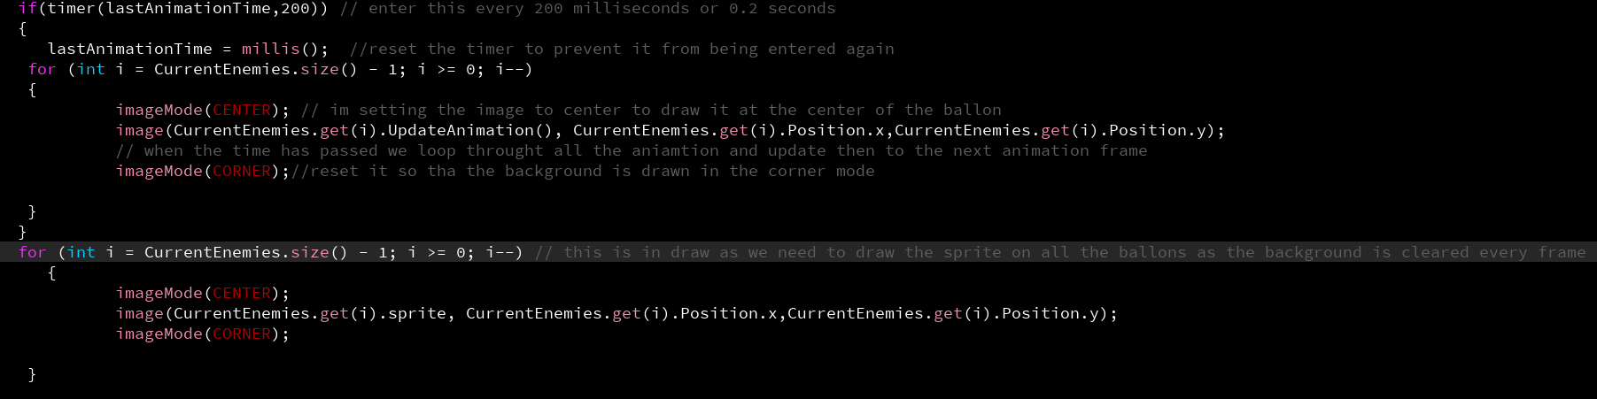
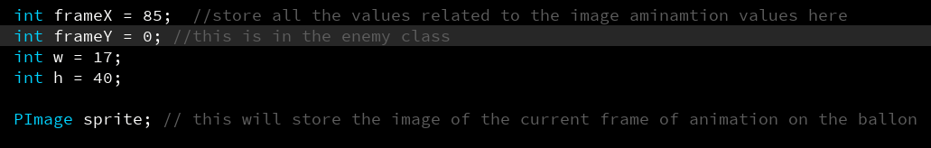
Global variables in the Enemy class
A new type of enemy has now been added with a new class that inherits from the Enemy.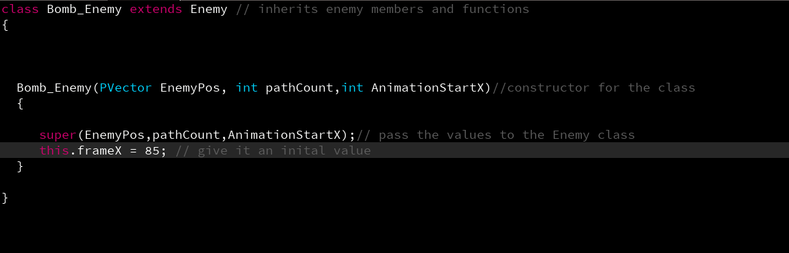

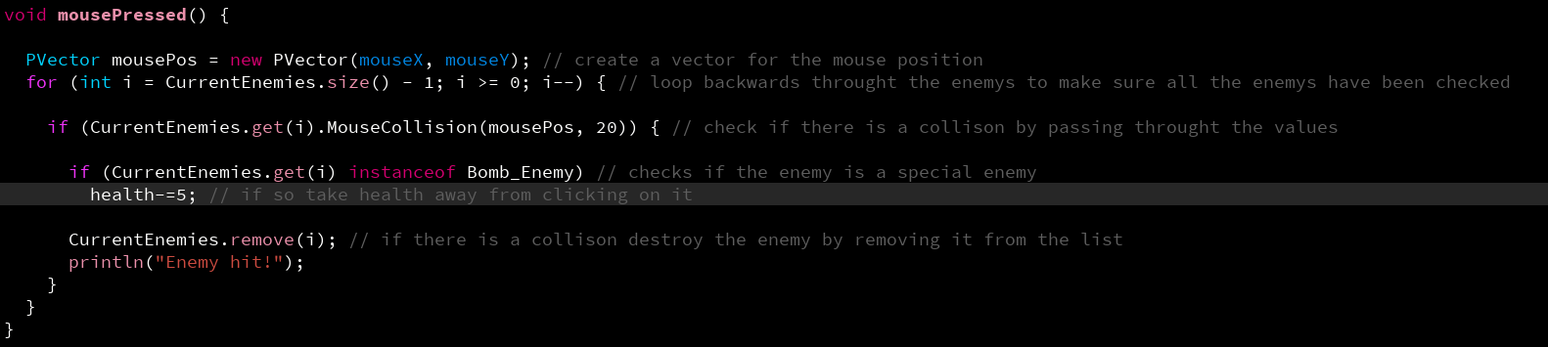

File saving has now been added to store the high score.
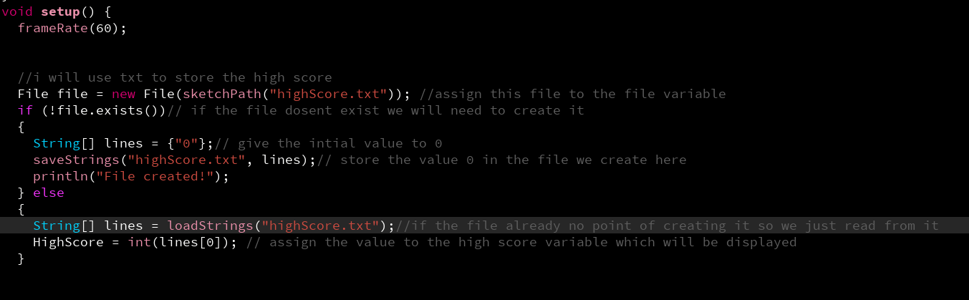
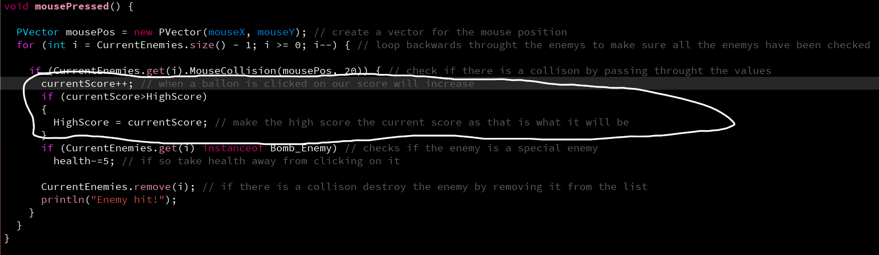
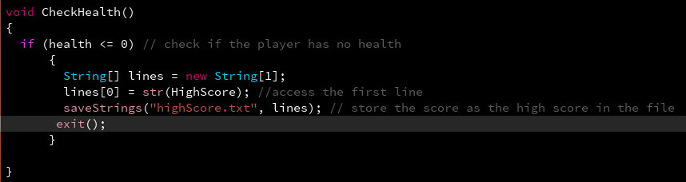
This code was refactored, and an error was fixed, as an item was first being removed and then modified when it should have been the other way around. The code is now being refactored further to make it more maintainable.
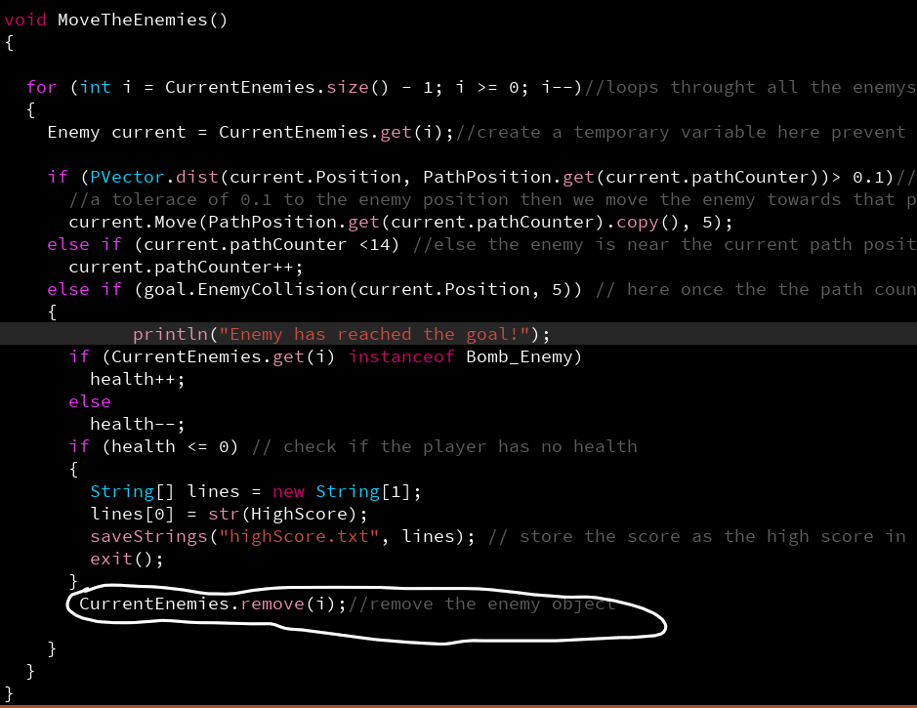
These two redundant for loops were removed using polymorphism.
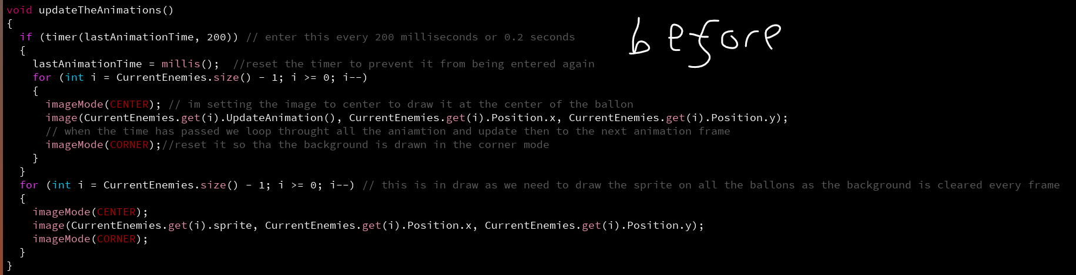

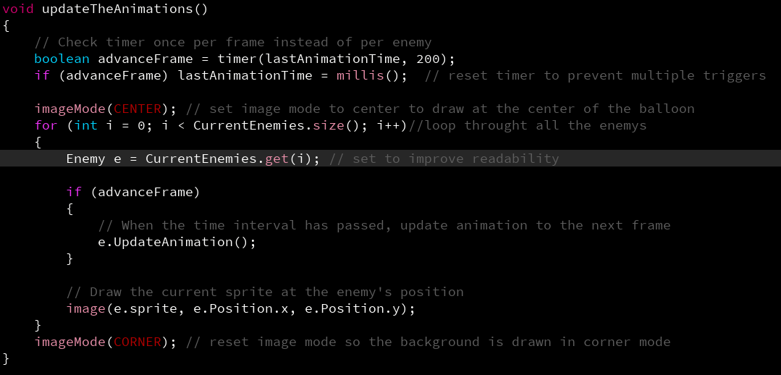
All constant variables and normal values were also placed at the start, and magic numbers were removed.
These are global variables in the ballonDefense class

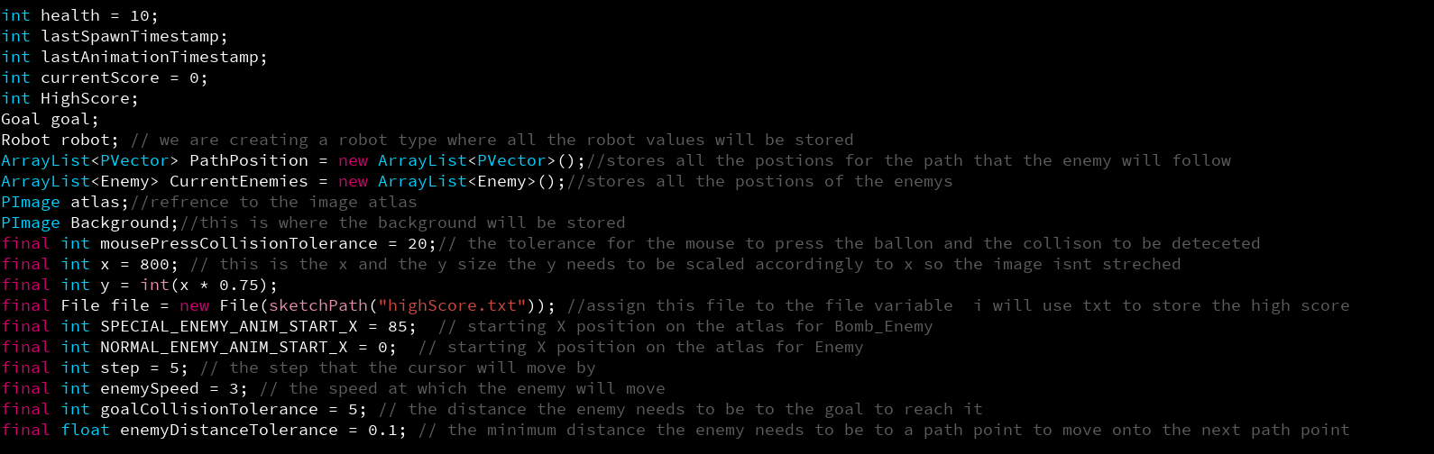
The same was done in the enemy class.
These are global variables in the Enemy class
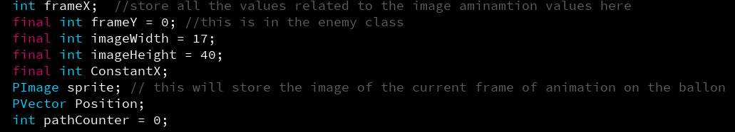
There was a glitch where the health could be 0, so a new procedure was made to check if the health is 0 in two separate places.
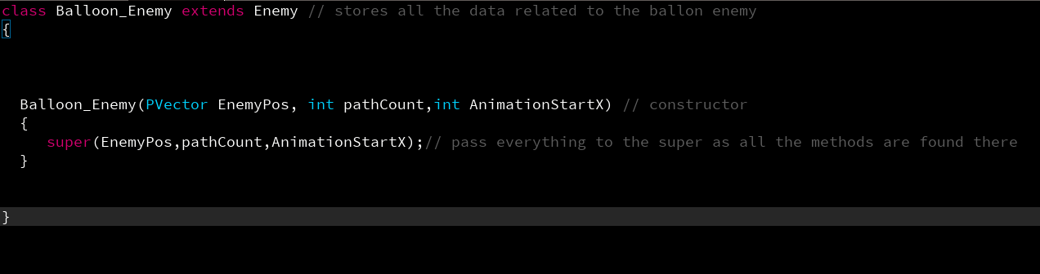
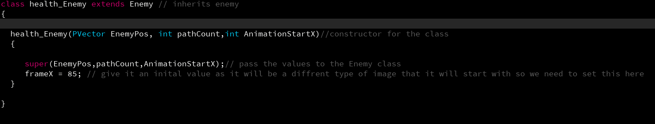
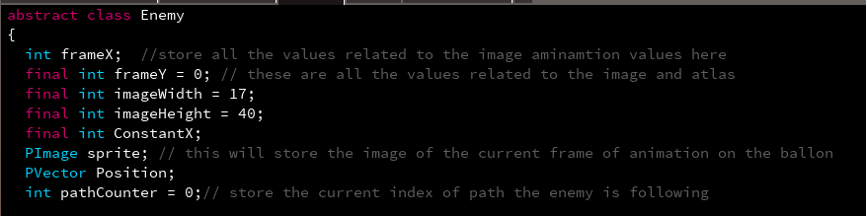
An explosion animation has now also been made by creating a new class that plays the animation every time an enemy is clicked on. The enemy is removed, but the explosion is added to a list that stores explosions, and then everything in the explosions list is animated to show an explosion until it is over, after which it is removed from the list.
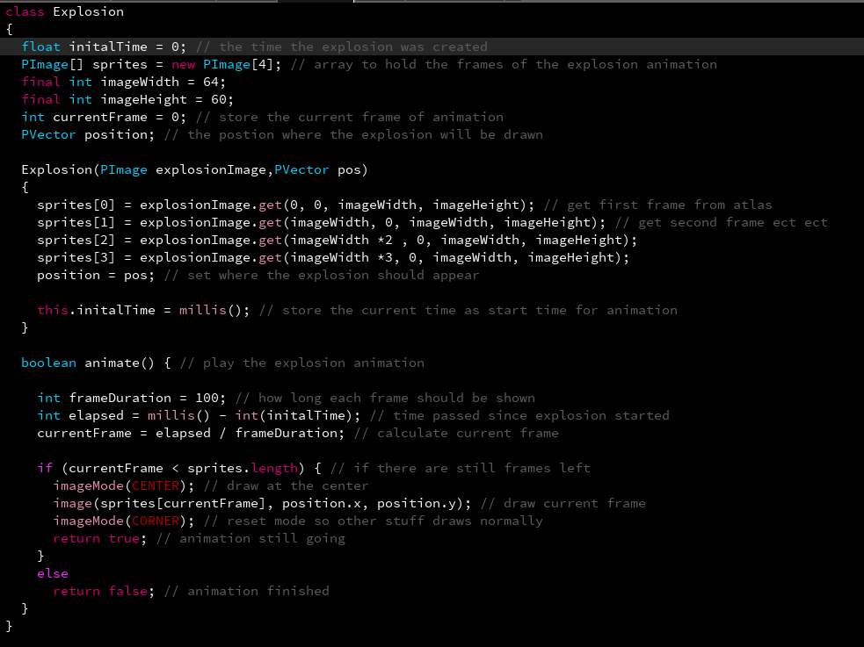
Global variable in the BallonDefense class
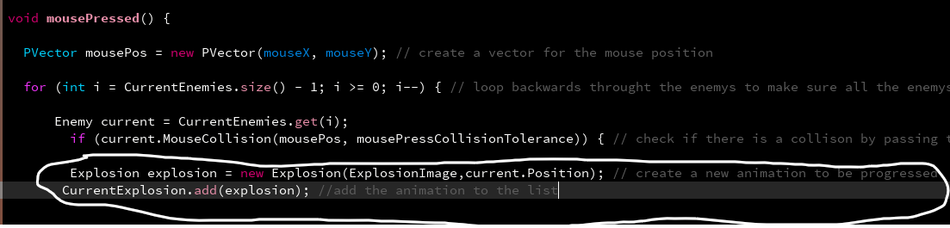

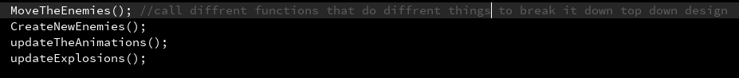
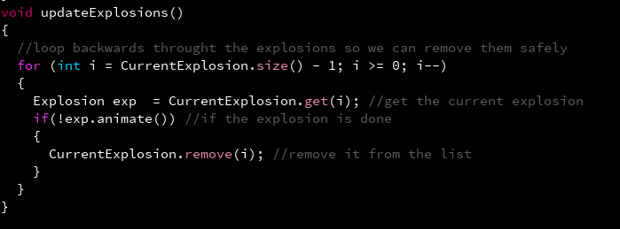

A game-over screen has also been added, along with a splash screen that will be added.
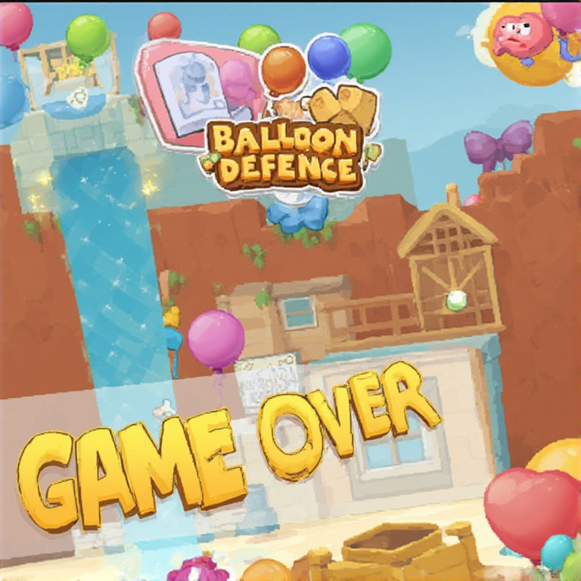

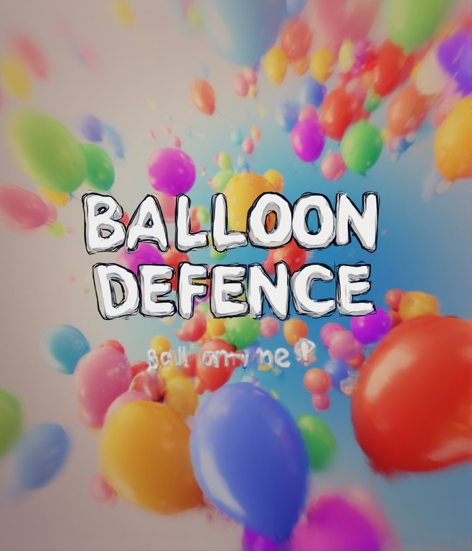

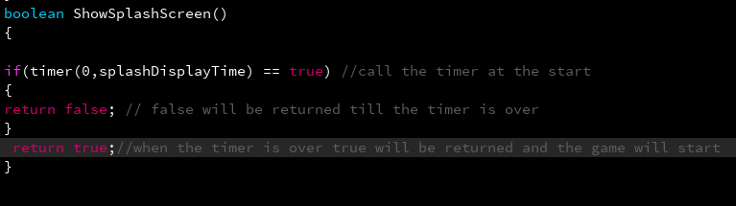

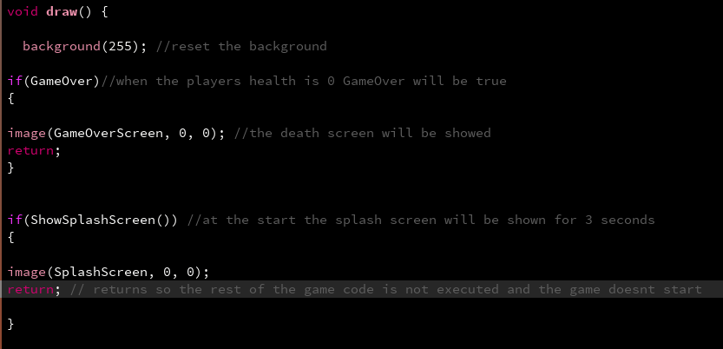
Now both the splash screen and game-over screen are shown at the same time

The file saving is correct; however, sometimes there's an issue with the path not being able to be accessed and therefore, the score sometimes isn’t saved and loaded.

